High Level Design (HLD)
Loan Management System (LMS)

1.System Overview
The Loan Management System (LMS) is a digital platform designed to manage the complete lifecycle of loans, from application submission to final closure. The system allows customers to explore loan products, apply for loans, track application status, and manage repayments. Internal operational users handle loan review, decisioning, disbursement, and closure through a separate administrative interface.
The system is designed with Banking and Financial Services (BFS) grade considerations, ensuring security, auditability, consistency, financial accuracy, and reliability across all workflows.
1.1Tech Stack
Frontend
- React.js – User interface for customers and managers
- JavaScript – Client-side logic
- Axios – API communication
- CSS / Bootstrap – UI styling
Backend
- Spring Boot – REST API and business logic
- Java – Backend programming language
- Spring Security + JWT – Authentication and authorization
Database
- MongoDB – Storage for users, loans, EMIs, and transactions
Configuration & Security
- application.yml / .env – Configuration management
- BCrypt – Password encryption
Tools
- Git – Version control
- Postman – API testing

1.2 Objectives
The objectives of the Loan Management System (LMS) are as follows:
- To provide a digital platform for customers to apply for and manage different types of loans.
- To support the complete loan lifecycle from application submission to final loan closure.
- To enable controlled loan approval and disbursement through internal operational workflows.
- To ensure financial accuracy and consistency in EMI calculation, repayment tracking, and loan balances.
- To enforce Banking and Financial Services (BFS) grade constraints such as security, auditability, and reliability.
- To maintain clear separation between customer-facing operations and administrative activities.
- To provide visibility into loan status, repayments, and transaction history for users.
- To design the system in a modular and scalable manner for future enhancements.

2. Actors and Roles
Actor | Responsibility
Customer | Apply for loans, track loan status, and repay EMIs
Manager | Review applications, approve or reject loans, disburse funds, and close loans
System services and audit mechanisms are internal components and are not treated as actors.

3. System Context Definition
3.1 LMS System Boundary
The LMS is responsible for loan lifecycle management, repayment handling, and operational control. It does not manage external banking systems or credit bureaus directly but integrates with them conceptually.
3.2 Internal Components
- Loan Origination
- Credit Decisioning
- Disbursement
- Repayment Scheduling
- Repayment Tracking
- Wallet Management
- Audit and Observability
3.3 External / Conceptual Dependencies
- Credit Bureau (for eligibility and credit checks)
- Payment Gateway / Banking System (for fund movement)
3.4 User Entry Points
- Customer Application (pre-login and post-login)
- Admin Application (restricted internal access)

4. Supported Loan Types
Loan Type | Description
Personal Loan | Short-term consumer loans
Education Loan | Long-term academic loans
Business Loan | Loans for business or self-employed users
Vehicle Loan | Loans for purchasing new or used vehicles

5. Component Architecture
The component architecture of the Loan Management System defines the major functional components of the system and the responsibility of each component. The LMS is structured as a modular monolithic application where each component addresses a specific business capability while remaining part of a single deployable system.
Each component operates within clear boundaries to ensure separation of concerns, maintainability, and BFS-grade reliability.

5.1 Authentication and Authorization Component
Responsibility
Manages user and administrator authentication and enforces role-based access control across the system.

5.2 Loan Origination Component
Responsibility
Handles loan application creation and maintains the initial stages of the loan lifecycle.

5.3 Eligibility and Credit Evaluation Component
Responsibility
Validates applicant eligibility and creditworthiness using predefined rules and risk checks.

5.4 Credit Decisioning Component
Responsibility
Determines loan approval or rejection based on eligibility results and business policies.

5.5 Disbursement Component
Responsibility
Processes loan amount disbursement for approved loans and updates loan disbursement status.

5.6 Wallet Management Component
Responsibility
Maintains customer wallet balances used for loan disbursement and repayment operations.

5.7 Repayment Scheduling Component
Responsibility
Generates EMI schedules based on loan amount, tenure, and interest rate after disbursement.

5.8 Repayment Tracking Component
Responsibility
Tracks EMI payments, outstanding balances, and repayment history throughout the loan tenure.
5.9 Ledger Component
Responsibility
Maintains immutable financial transaction records to ensure financial accuracy and traceability.
5.10 Audit and Observability Component
Responsibility
Captures and stores audit logs and operational events to support compliance, monitoring, and traceability.

6. End-to-End User Flow
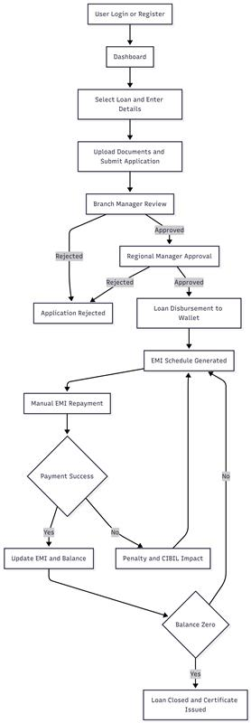

7. Loan Lifecycle
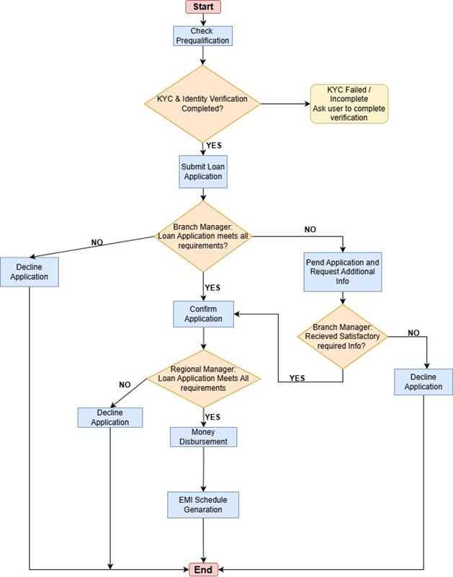
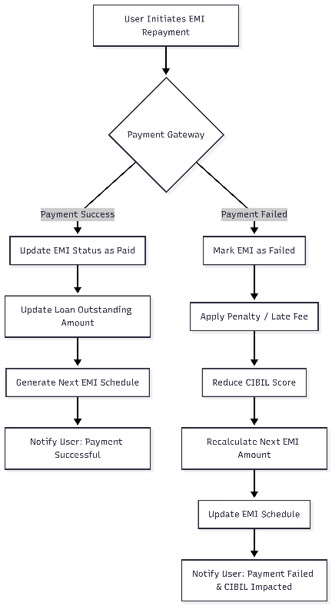
8. API Overview (HLD Level)
API Category | Used By | Purpose
Authentication APIs | Customer, Manager | User authentication and session management
Loan Application APIs | Customer | Loan creation and submission
Eligibility APIs | Customer | Eligibility and credit validation
Loan Decision APIs | Manager | Loan approval or rejection
Loan Status APIs | Customer | Loan tracking and visibility
Repayment APIs | Customer | EMI schedule and repayment recording
Wallet APIs | Customer | Temporary fund holding and payment handling

9. Data Flow
9.1 User Registration and Login Flow
- User registers with basic details.
- System validates input data.
- Password is securely encrypted and stored.
- User logs in using credentials.
- Authentication token is generated.
- User is redirected to the dashboard.
9.2 Wallet Top-Up Flow
- User selects Wallet → Add Money.
- User enters the amount to be added.
- User chooses a payment method (UPI, Debit Card, Net Banking).
- Payment gateway processes the transaction.
- On successful payment:
  - Wallet balance is increased.
  - Transaction record is created.
  - Transaction status is marked as CREDITED.
- Wallet balance is used for loan repayment and EMI payments.
9.3 Loan Application Flow
- User selects a loan type.
- Loan details and eligibility information are displayed.
- User enters loan amount and tenure.
- Required documents are uploaded.
- Loan application is submitted.
- Loan record is created in the system.
- Loan status is set to SUBMITTED.
9.4 Loan Review and Approval Flow
- Branch manager reviews submitted loan applications.
- Documents, income details, and credit history are verified.
- Branch manager approves or rejects the application.
- Approved applications are forwarded for regional approval.
- Regional manager performs final review.
- Final approval or rejection is recorded.
- Approved loans move to disbursement.
9.5 Loan Disbursement Flow
- Approved loan amount is processed.
- Loan amount is credited to the user’s wallet.
- Wallet transaction entry is created.
- EMI schedule is generated.
- Loan status is updated to DISBURSED.
9.6 Manual Loan Repayment Flow
- User accesses My Loans → Repay Loan from the dashboard.
- System displays EMI details and outstanding balance.
- User chooses repayment type:
  - Monthly EMI
  - Partial prepayment
  - Full foreclosure
- Repayment amount is deducted from wallet.
- Repayment transaction is recorded.
- EMI schedule and outstanding balance are updated.
- Repayment history is stored.
9.7 Loan Closure Flow
- When outstanding balance becomes zero:
  - Loan status is updated to CLOSED.
  - Loan completion certificate is generated.
  - Loan account becomes read-only.

10. BFS Constraint Mapping
BFS Constraint | Design Enforcement
Security | Authentication, RBAC, encrypted data
Auditability | Immutable audit logs
Data Consistency | Strict lifecycle transitions
Financial Accuracy | Ledger-based accounting
Idempotency | Duplicate request prevention
Reliability | Controlled workflows and retries

11. Data Model (High-Level)
Entity | Description
Customer | Applicant information
Loan | Loan record and lifecycle state
Repayment Schedule | EMI plan
Ledger Entry | Financial transactions
Wallet | Temporary fund holding
Audit Log | System activity history
12. Synchronous and Asynchronous Operations
Operation | Execution Type
Loan creation | Synchronous
Eligibility check | Synchronous
Decision execution | Synchronous
Disbursement | Synchronous
EMI schedule generation | Asynchronous
Notifications | Asynchronous
13. Non-Functional Requirements (NFRs)
This section defines the non-functional requirements that govern the quality, scalability, security, and maintainability of the Loan Management System (LMS). These requirements directly influence architectural and design decisions across the system.
13.1 Security
Requirement
The system must ensure confidentiality, integrity, and secure access to user and financial data.
Design Impact
- Authentication and authorization using Role-Based Access Control (RBAC)
- Encryption of sensitive data such as Aadhaar, PAN, and credit score information
- Secure API communication over HTTPS
- Restricted access to financial, KYC, and audit data

13.2 Performance
Requirement
The system must efficiently handle high volumes of user requests and financial transactions.
Design Impact
- Use of high-performance data stores for fast read/write operations
- Indexing on frequently accessed attributes such as userId, loanId, and transactionId
- Asynchronous processing for EMI calculations and background jobs
- Optimized API responses to minimize latency

13.3 Observability
Requirement
The system must provide visibility into application behavior, errors, and transaction flows.
Design Impact
- Centralized logging of user actions and system events
- Monitoring of API response times and failure rates
- Tracking of loan lifecycle and transaction state transitions
- Error tracing to support debugging and root-cause analysis

13.4 Reliability
Requirement
The system must remain operational and consistent even in the presence of partial failures.
Design Impact
- Fault-tolerant service design
- Graceful handling of failed payments or EMI processing
- Data consistency enforced through controlled transaction boundaries
- Retry mechanisms for critical operations

13.5 Idempotency
Requirement
Repeated or duplicate requests must not result in inconsistent or duplicate financial transactions.
Design Impact
- Unique identifiers for transactions and payment requests
- Idempotent handling of payment and EMI operations
- Safe retry mechanisms for network or service failures
- Prevention of duplicate wallet deductions or EMI postings

13.6 Testability
Requirement
The system must support effective unit, integration, and system-level testing.
Design Impact
- Clear separation of business logic and API/controller layers
- Use of mockable services and repositories
- Isolated testing of eligibility logic, EMI calculations, and payment flows
- Support for automated testing pipelines

13.7 Modularity
Requirement
The system must support independent development, maintenance, and scaling of features.
Design Impact
- Modular architecture with separate components for Users, Loans, Payments, and EMIs
- Independent loan type modules (Personal, Education, Vehicle, Business)
- Separate frontend applications for Customer and Admin interfaces to isolate responsibilities
- Loose coupling between components to reduce the impact of changes
- Simplified enhancement and scalability of the system

14. Scope Boundaries
This HLD defines system structure, components, workflows, and BFS constraints.
Implementation details such as database schemas, exact APIs, and code logic are intentionally excluded and addressed in the Low-Level Design (LLD).

15. Conclusion
The Loan Management System (LMS) is designed as a secure, scalable, and auditable platform that supports the complete loan lifecycle, from application submission to final loan closure. The architecture clearly separates customer-facing functionalities from administrative operations, ensuring controlled workflows and role-based access.
By applying Banking and Financial Services (BFS) grade constraints such as security, auditability, data consistency, financial accuracy, and reliability, the system ensures safe handling of sensitive data and financial transactions. The modular design enables maintainability and future enhancements while preserving system stability.
This High-Level Design provides a strong architectural foundation for implementation and serves as a clear reference for development, testing, and future system evolution

